Temperature and Humidity Recording Dashboard
SH104MT
User Manual

Thanks for purchasing this Temperature and Humidity Recording Dashboard (SH104MT).
It not only measures but records the temperature and humidity. Be suitable for transportation, medicine & food storage, wine cooler, cigar humidor, moisture-proof boxes and other equipments which need monitor and record the temperature and humidity. Mini body design to be perfect for placing inside of the cigar humidor and wine cabinet. Rear installed with magnetism for being adhered on metal surface.

Feature and specification
※ Display temperature, humidity, clock and date
※ Check the hourly average temperature and humidity for last 24 hours
※ Memory clean and ℃/ ℉ display conversation
※ Calibration at 75%
※ The orange backlight is on when touch the SET button
※ Powered by one CR2032 (pre-loaded with insulation tap)
※ Panel mount and magnetic adhesive solution are compatible
※ Temperature measuring range: 14℉~140℉ (-10℃-60℃)
※ Humidity measuring range:10%~99%RH
※ Accuracy：±2℉ (±1℃)；
±3%RH (30%~80%RH), ±5%RH for beyond (30%~80%RH)
※ Product Size：D2.36*H0.63 inches (D60*H16 mm)
※ Product Tail Diameter: 2.27 inches (57.7 mm)
※ Mount Hole Diameter: Between 2.36 inches and 2.27 inches (60.00 mm and 57.70 mm)

Appearance sketch:
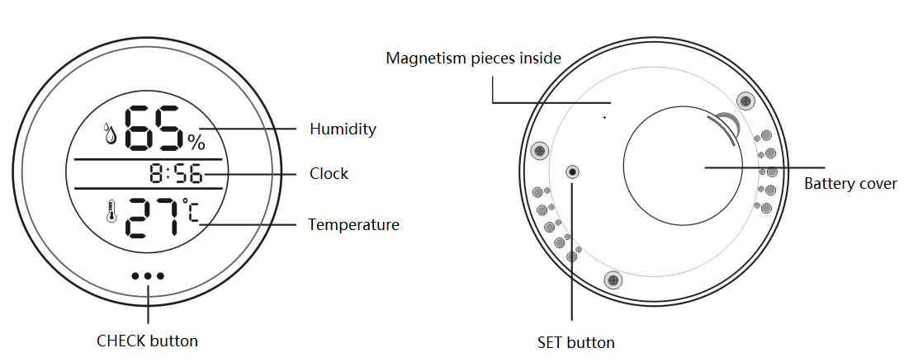

Operation Guide
－Battery loading
Open battery cover, take out the insulation tap. Load the battery refer to the below sketch.
There are Positive and Negative pins. Let the Positive pin contacts with battery "+", and the Negative contacts with battery "-". Don't place both of the Positive and Negative pins under the battery to touch battery "-".
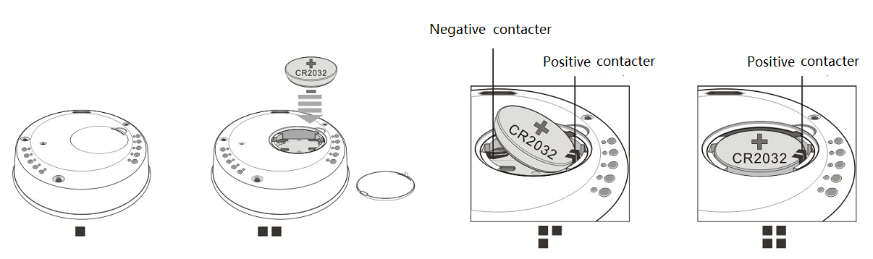
Note: Don't touch 。。。button when load the battery, otherwise it will make the product dead. If the product is dead, please reload battery to recover it.

－℃/ ℉ display conversion
After load the battery, the backlight will be on for 1 second then the default unit ℃ flashes. Touch。。。button to convert to ℉ and then press the SET button by a pen-point to confirm. If there is no operation on SET button for 10 seconds, the screen will back to measure status.

－Set date and clock
Press and hold SET button for 3 seconds by a pen-point.
(figure 1) : 16 of 2016 is flashing, touch 。。。button to adjust the year number, then press SET button to confirm.
(figure 2) : The month number 01 is flashing, touch 。。。button to adjust, then press SET button to confirm the set.
(figure 3) : The day number 01 is flashing, touch 。。。button to adjust, then press SET button to confirm the set.
(figure 4) : The 24HR format is flashing, touch 。。。button to select, then press SET button to confirm.
(figure 5) : 12 of hour is flashing, touch 。。。button to adjust hour value, then press SET button to confirm.
(figure 6) : 01 of minute is flashing, touch 。。。button to adjust minute value, then press SET button to confirm. After finish the date and clock set, the screen back to normal measure status.
Note: If there is no operation on SET button for 10 seconds, the set will be memorized and back to normal measure status automatically.
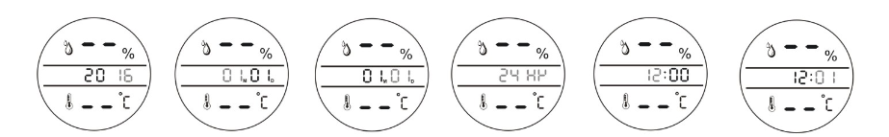
Figure 1 Figure 2 Figure 3 Figure 4 Figure 5 Figure 6

－Memory recording check
→Touch 。。。button, backlight is on.
→Touch 。。。button again, the past hour number and date flash, then display the average temperature and humidity records for relative past hour. No any button operation for 10 seconds to exist the memory checking and back to measure status.
For example:
→The current time is 8:56 of Jan 15th. First time to touch 。。。button, backlight is on.
→Touch 。。。button again to check the records for the last 1st hour (7:56). The display will be Figure 7 and Figure 8.
→Touch 。。。button the 3rd time to check the records for the last 2nd hour (6:56).
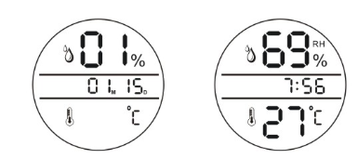
Figure 7 Figure 8

－Humidity calibration
Place the unit in the environment with constant humidity of 75% for 4 hours, if the humidity display has deviation ( for example 73%), push and hold 。。。button for 3 seconds till 75% flashes, press SET by a pen-point to confirm the calibration. Then screen back to normal measure status. Humidity calibration is done.
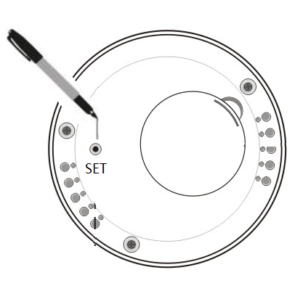
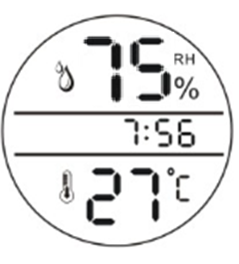

－Memory clean/reset
All memory and set will be cleaned once reload the battery.

www.fmg-tech.com.cn
sales@fmg-tech.com

